DA 570 Course Project 1 Watson Analytics by Joshua Troup

Screenshots of Steps 1-15

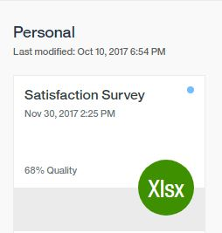

Step 1: Loading Data

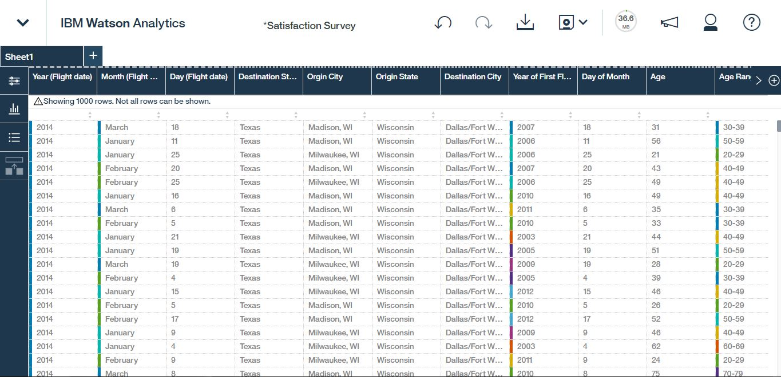

Step 2: Data Refinement (Make all hidden columns visible)

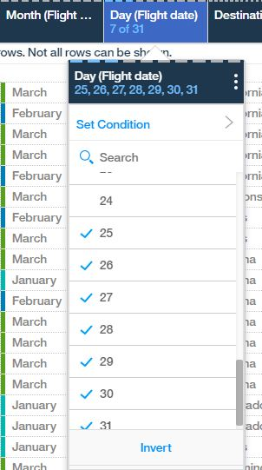

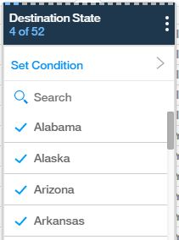

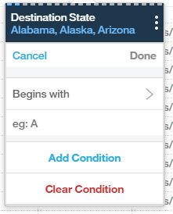

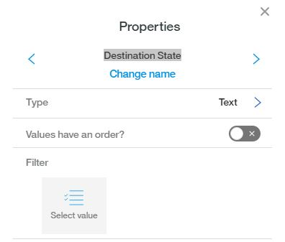

Step 3: Filter and rename columns

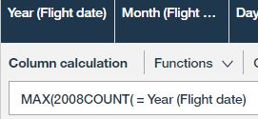

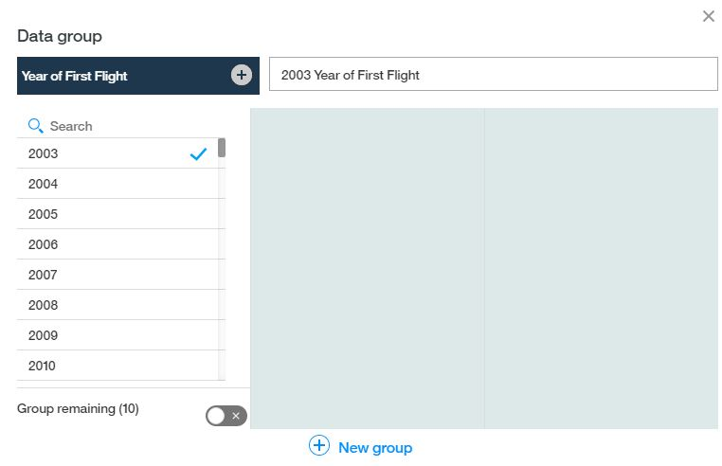

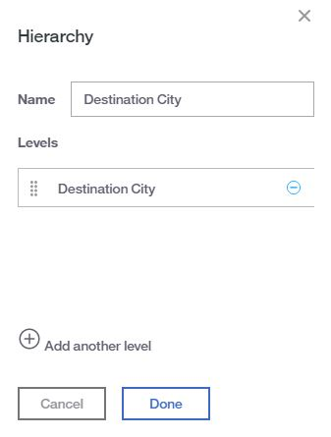

Step 4 - Calculations, Data Binning (Grouping), and Hierarchies

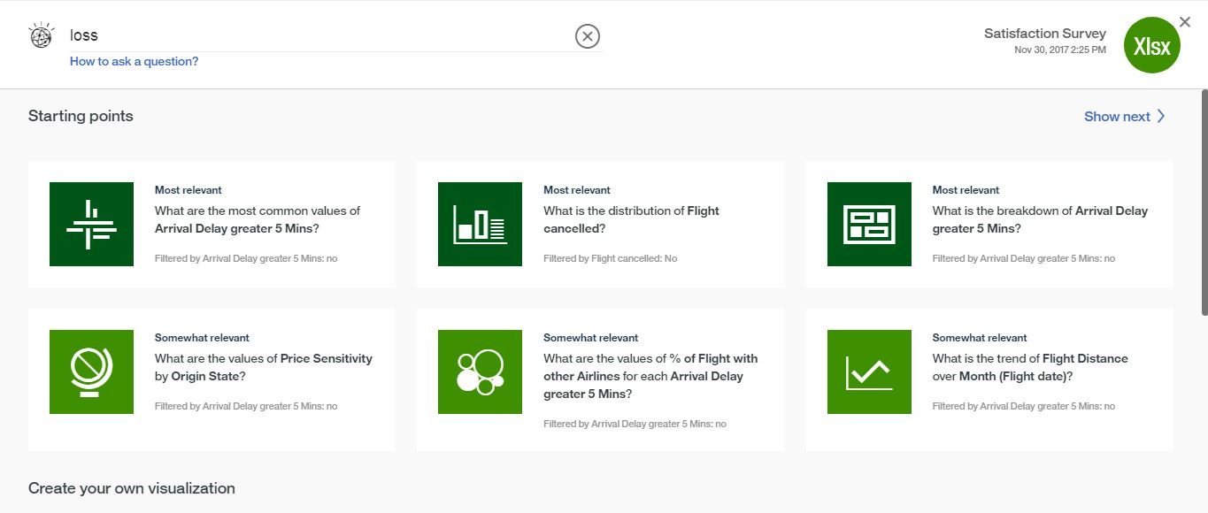

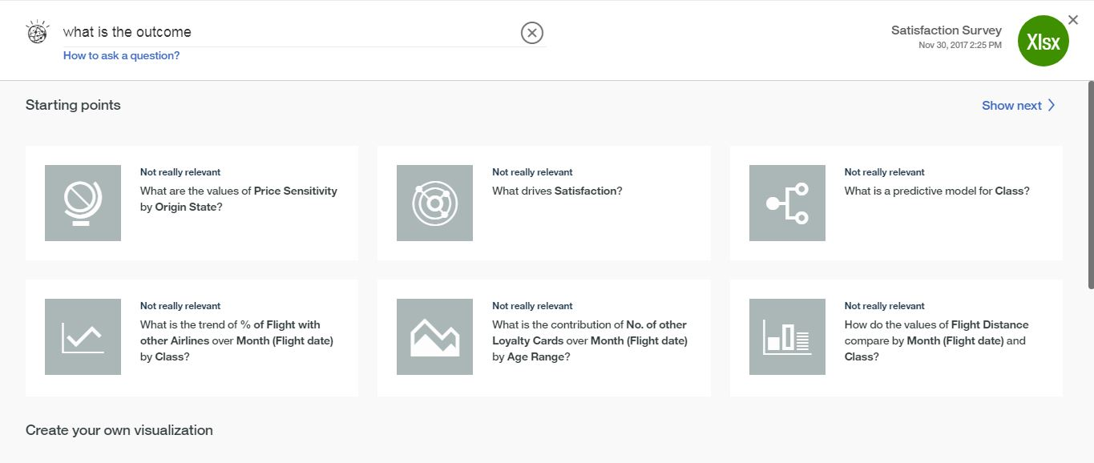

Step 5 - Ask questions

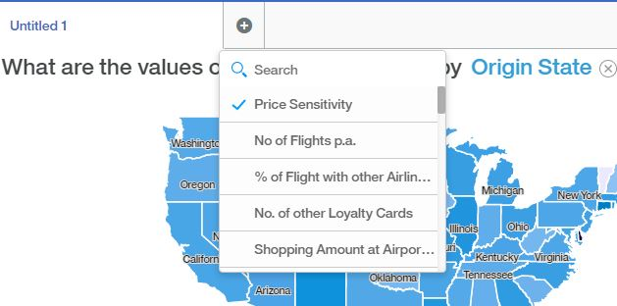

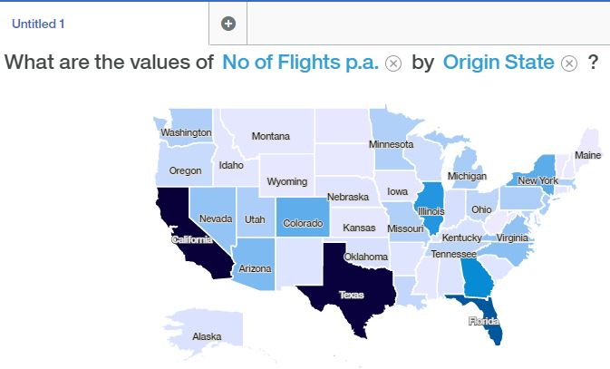

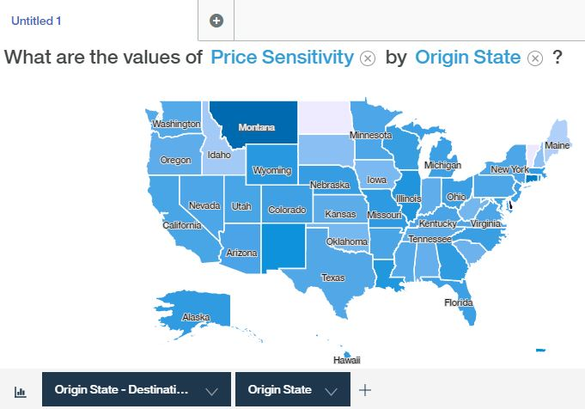

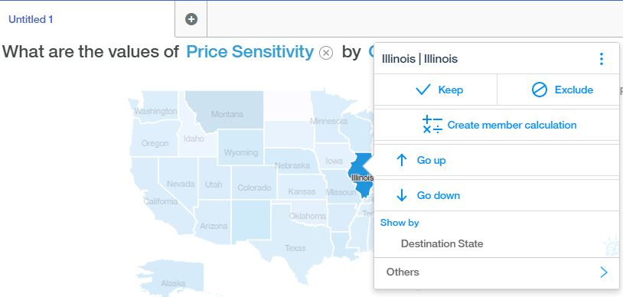

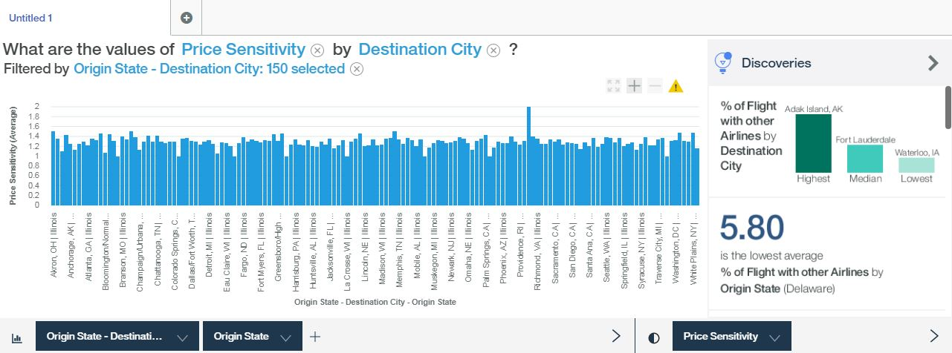

Step 6 - Changing elements of a visualization

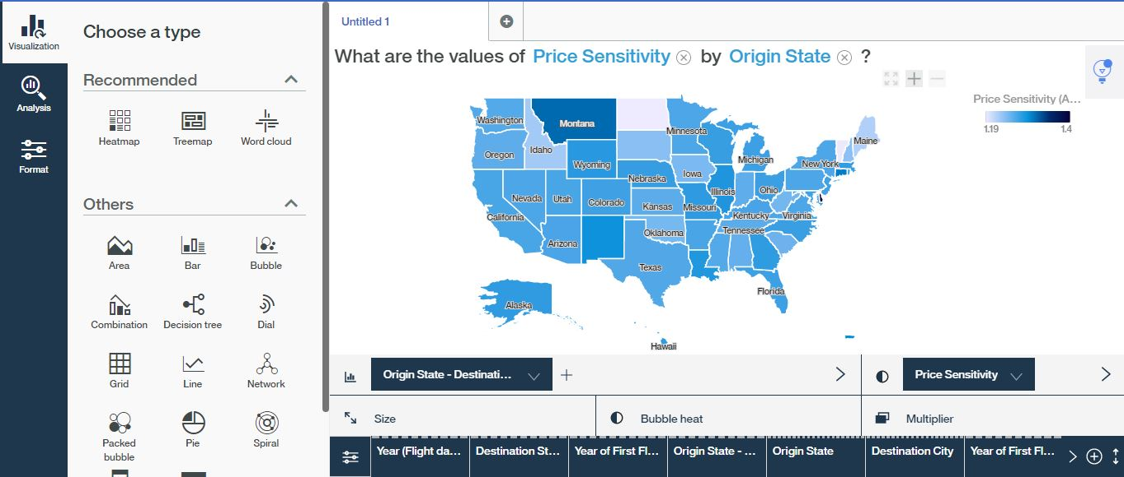

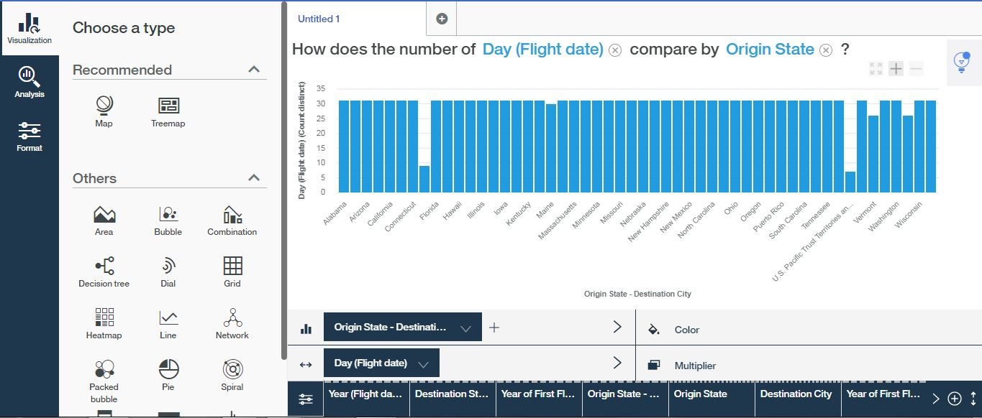

Step 7 - Augmenting visualizations, changing visualizations

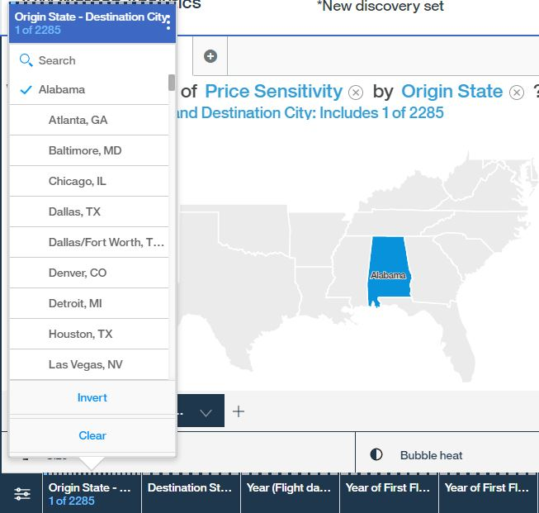

Step 8 – Local and Global Filtering

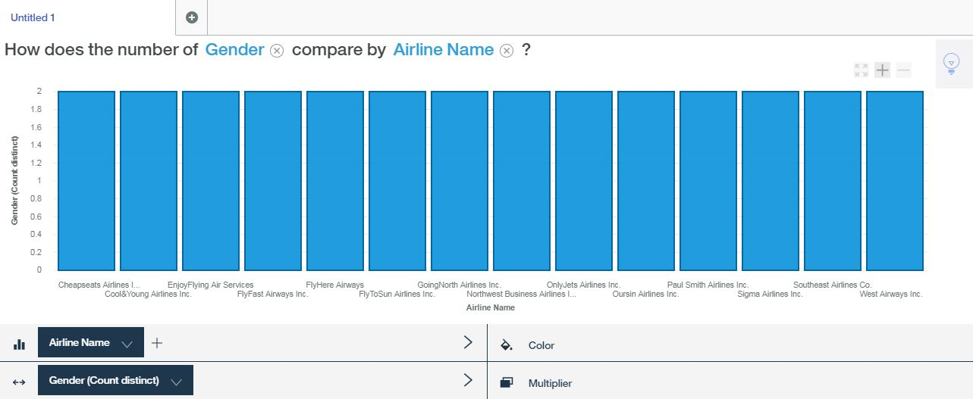

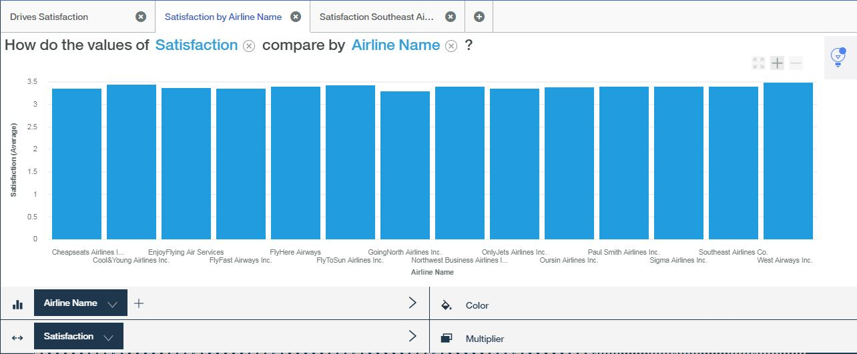

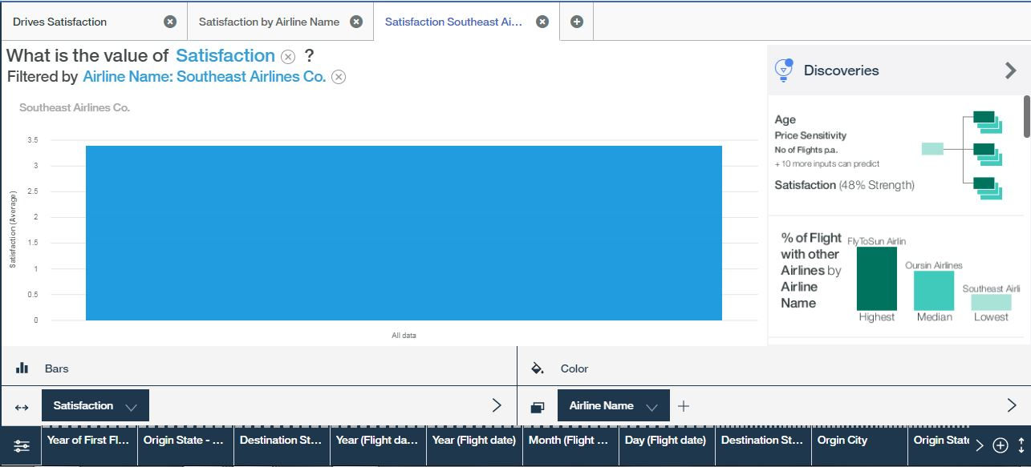



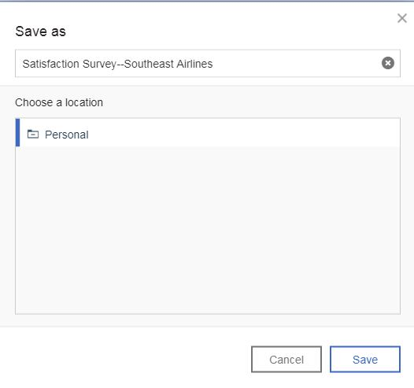

Step 9 – Data augmentation and other options

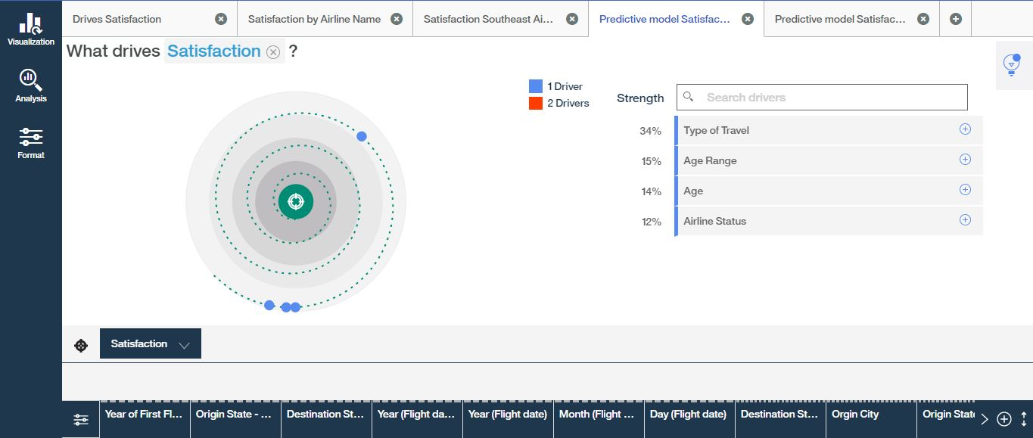

Step 10 – Creating a prediction

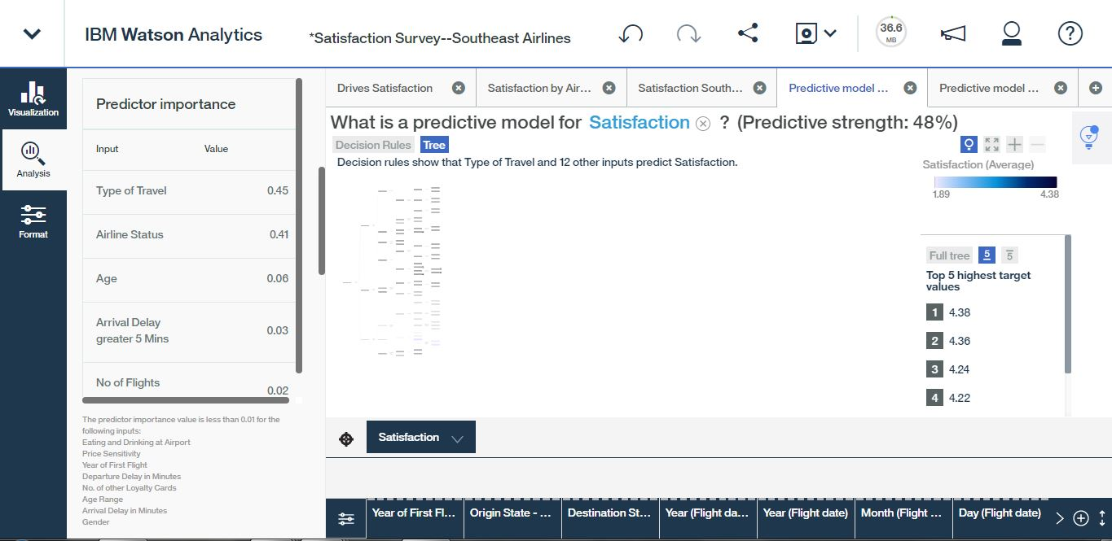

Step 11 – Consuming results of a predictive model

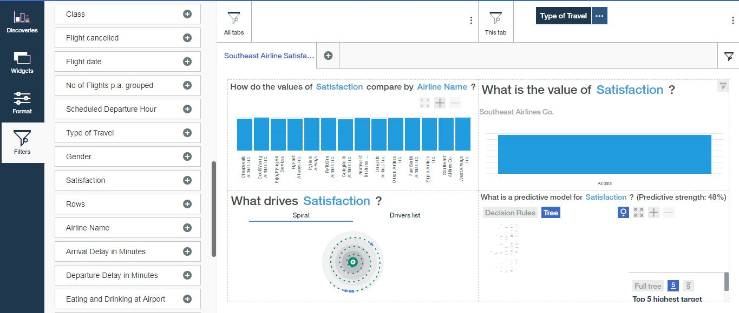

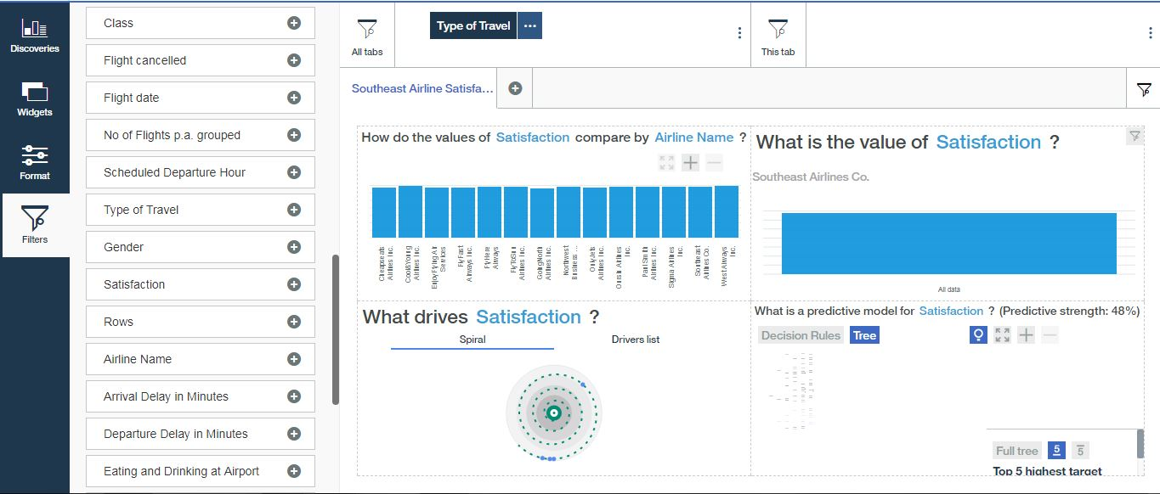

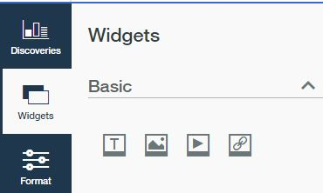

Step 14 – Filtering and multimedia

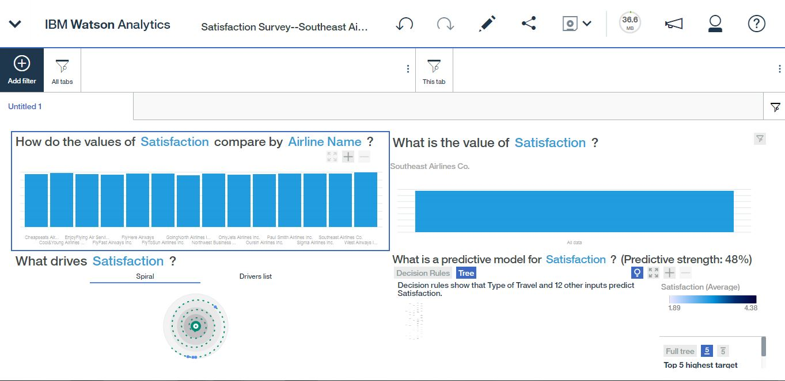

Step 15 – Creating a story

Questions

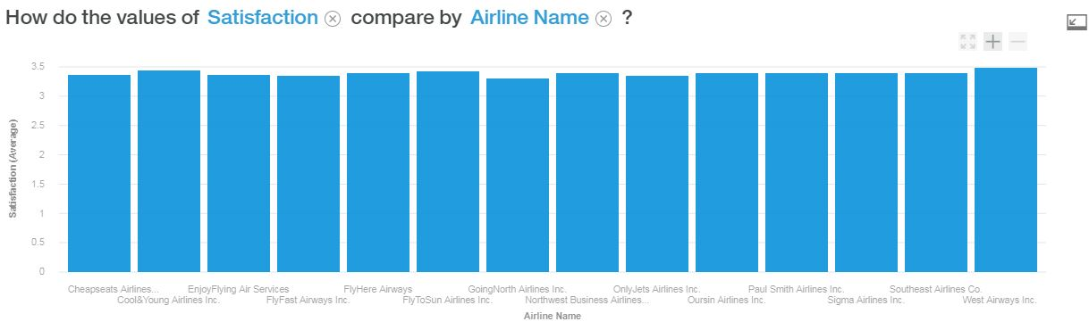

**How Do the Values of Satisfaction Compare by Airline name? What are your conclusions based on the output?**

The overall average values between airlines are very similar. GoingNorth Airlines has the lowest average of 3.30 satisfaction rate. West Airways has the highest satisfaction rate of 3.49. The bar graph above displays the averages in a easy to compare visualization.

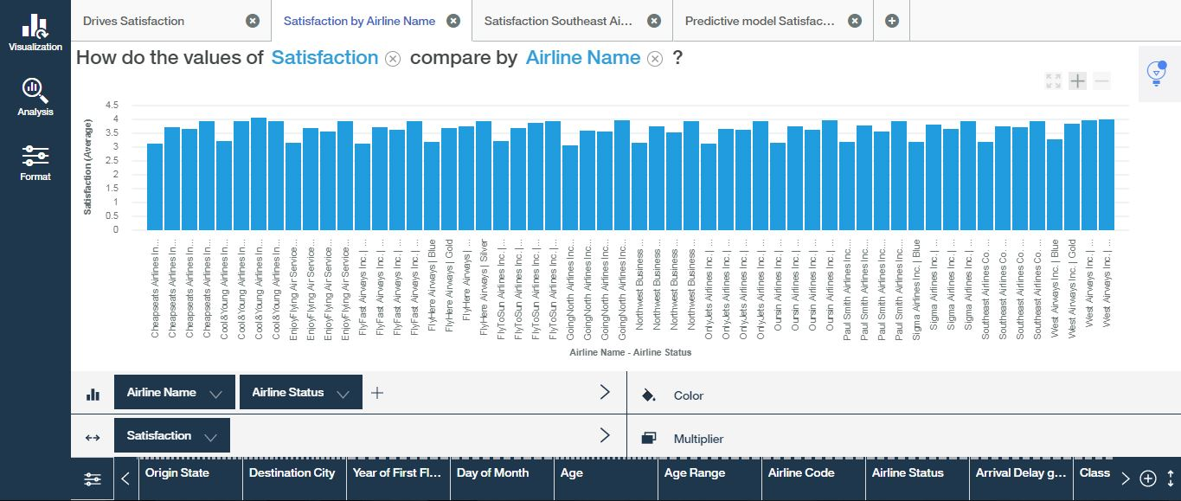

**How Do the Values of Satisfaction compare by Airline name and Airline status? Comment your findings.**

The bar graph above shows a correlation between Airline status and overall satisfaction value. Blue level status shows a lower overall satisfaction value across the graph showing a trend in all airlines. The higher level of status such as gold, platinum, or silver, the higher overall satisfaction value.

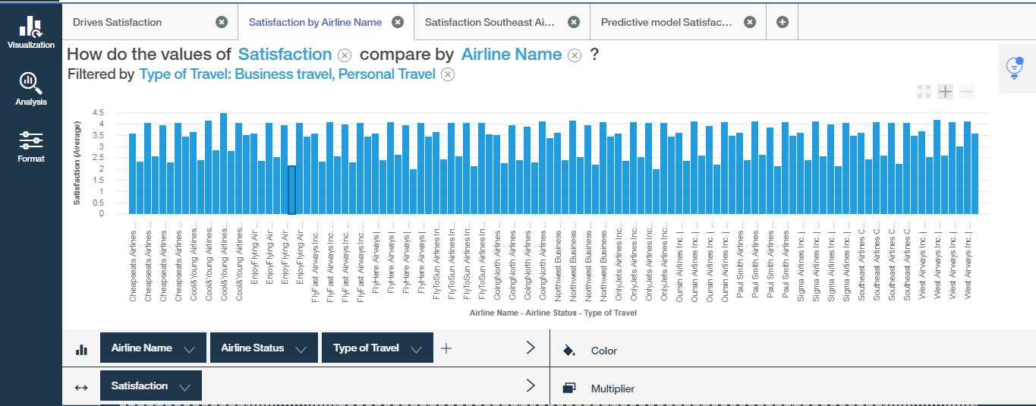

**Any other questions you may wish to analyze.----Is there a correlation between type of travel whether it be personal or business in regards to satisfaction and airline status?**

The bar graph displays the relationship between business travel, personal travel and with airline status with a satisfaction outcome rate. The trend seems to be significant in the majority lower average satisfaction values that were expressed from individuals on personal trips. Airline status is not based solely on blue class as many platinum members gave low values.

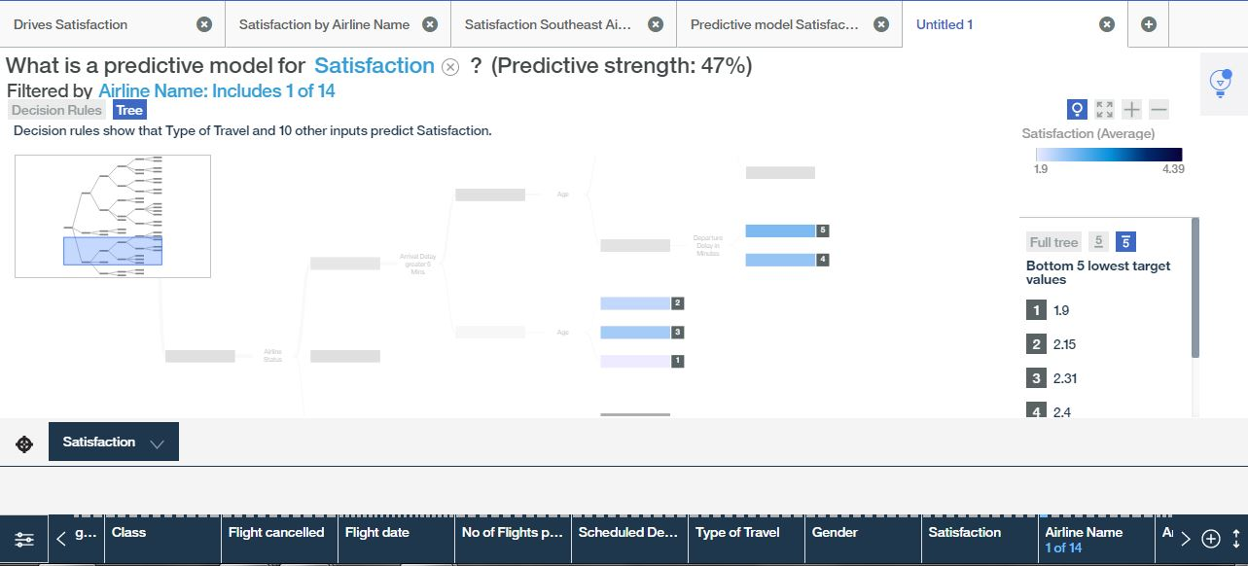

LOWEST

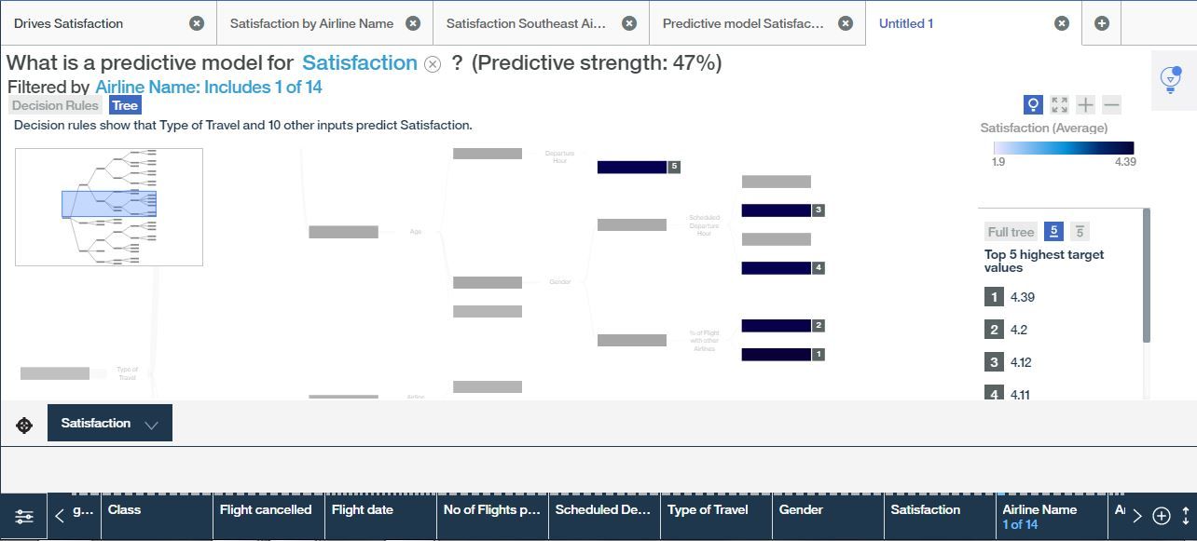

HIGHEST

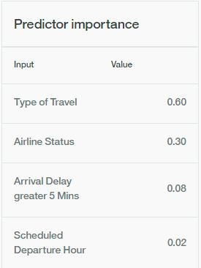

**Refine your model to include only Southeast and build a Decision Tree to show how Satisfaction is influenced by the Type of Travel and other variables?**



**LOWEST**

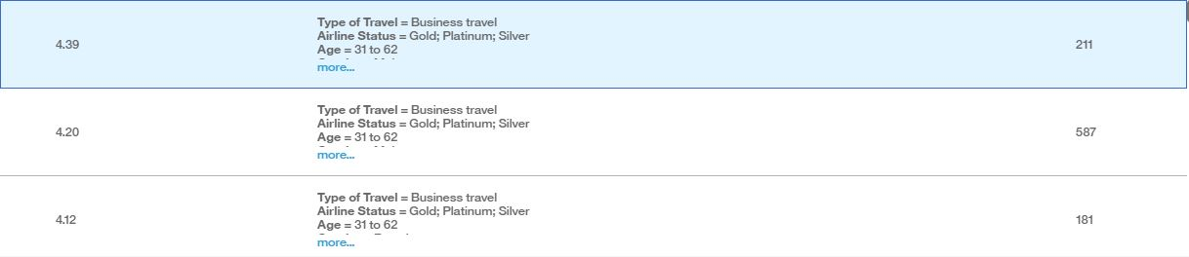

**HIGHEST**

**What are the Top Design Rules?**

**Final Conclusions from your findings**

The customers of Southeast Airlines who have blue and platinum status that travel for personal travel and their arrival delay greater than 5 minutes with an age less than 50 has a predicted satisfaction value of 1.90.

**Type of Travel**= Personal Travel

**Airline Status**= Blue; Platinum

**Arrival Delay greater 5 Mins**= yes

**Age**> 50

Male customers who have gold, platinum, or silver airline status for business travel and their age is between 31 and 62 who fly less than 12% with other airlines are predicted to give the highest satisfaction value of 4.39

**Type of Travel**= Business travel

**Airline Status**= Gold; Platinum; Silver

**Age**= 31 to 62

**Gender**= Male

**% of Flight with other Airlines**> 12

**SAMPLE DATA: IT Help Desk**

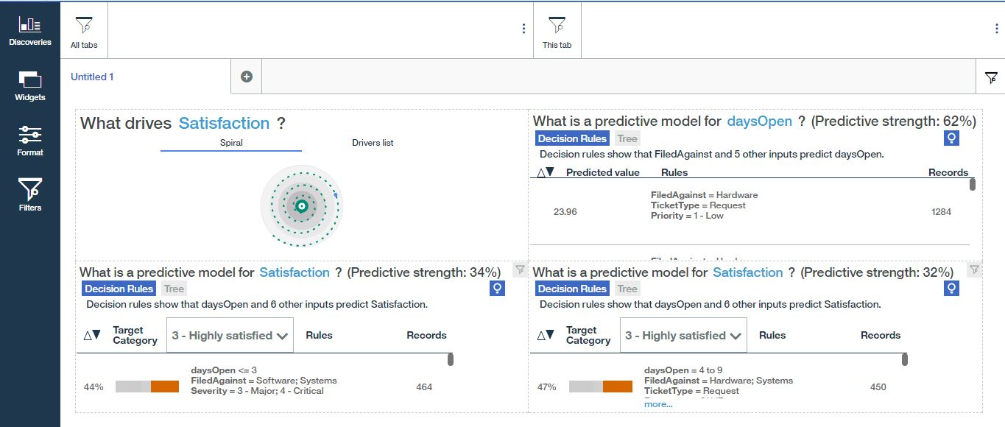

Display of four discoveries found in the IT Help Desk data pertaining to overall satisfaction and correlation with how many days the ticket is open.

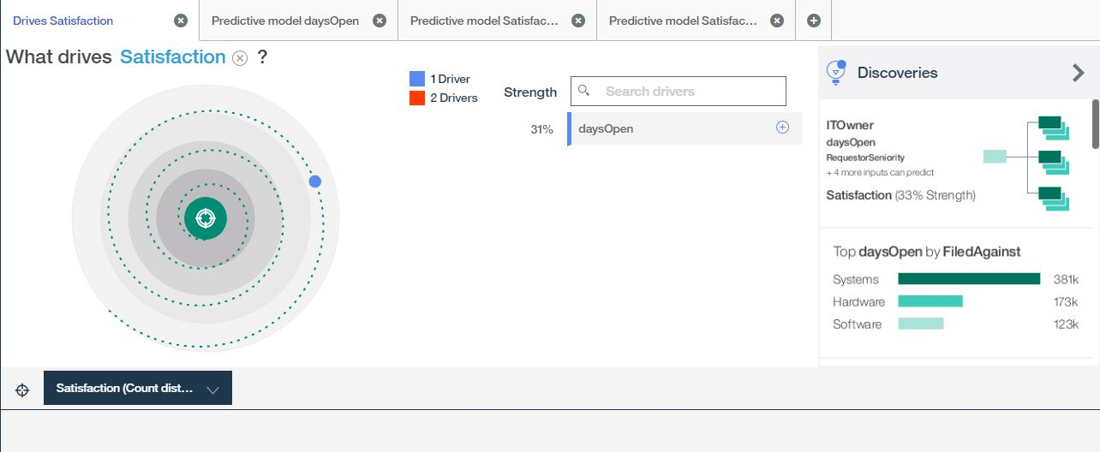

The number one driver of satisfaction according to the data is the amount of days the ticket stays open until the issue has been resolved.

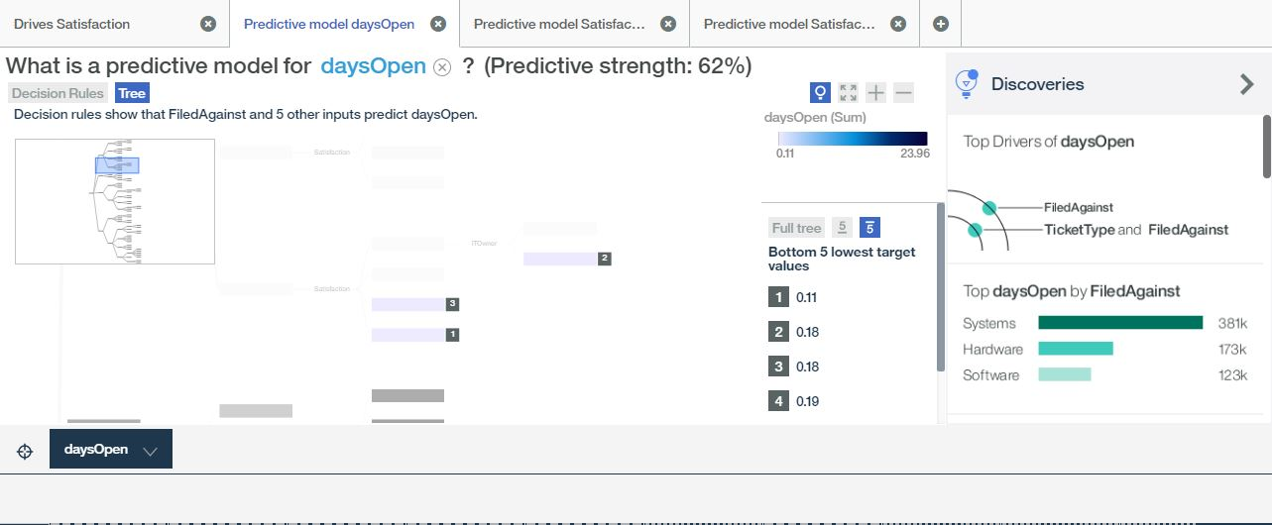

**LOWEST**

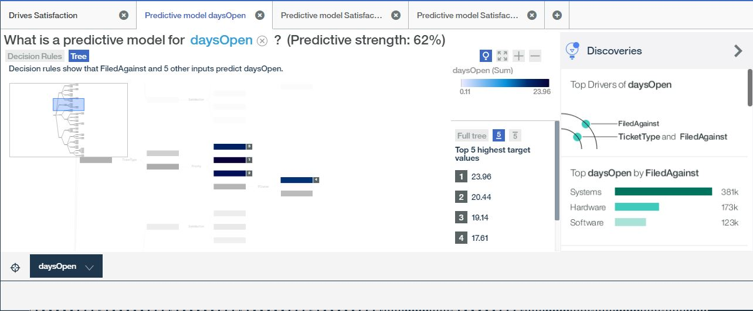

**HIGHEST**

The target values in the predictive model for daysOpen are displayed above in the decision tree. The lowest value is .11 which maybe a simple replacement part or login issue. The highest value is 23.96 leads to be a system related issue requiring more time to resolve the matter.

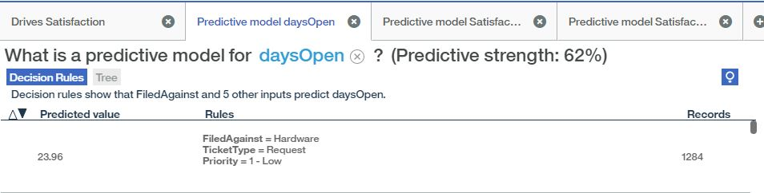

The number one decision rule with the predictor value of 23.96 states the rule as the filed against is hardware, ticket type is by request, and the priority is a 1 or considered low.



The last decision rule with the predictor value of .11 states the rule as an Access/Login issue with a priority of 3 and satisfaction rate of 3.

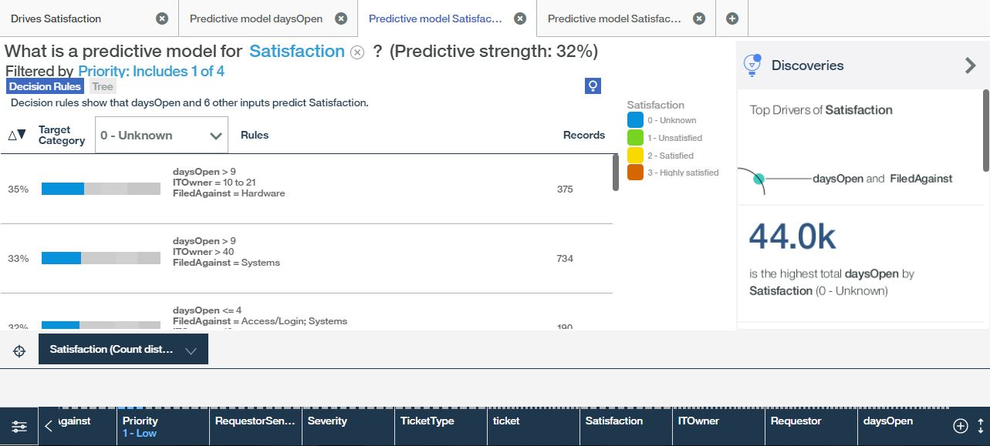

The predictive model for satisfaction based on a priority level of 1 shows a 35% rate when the ticket has been open less than 9 days, IT owner is 10 to 21, and the issue was filed against hardware.

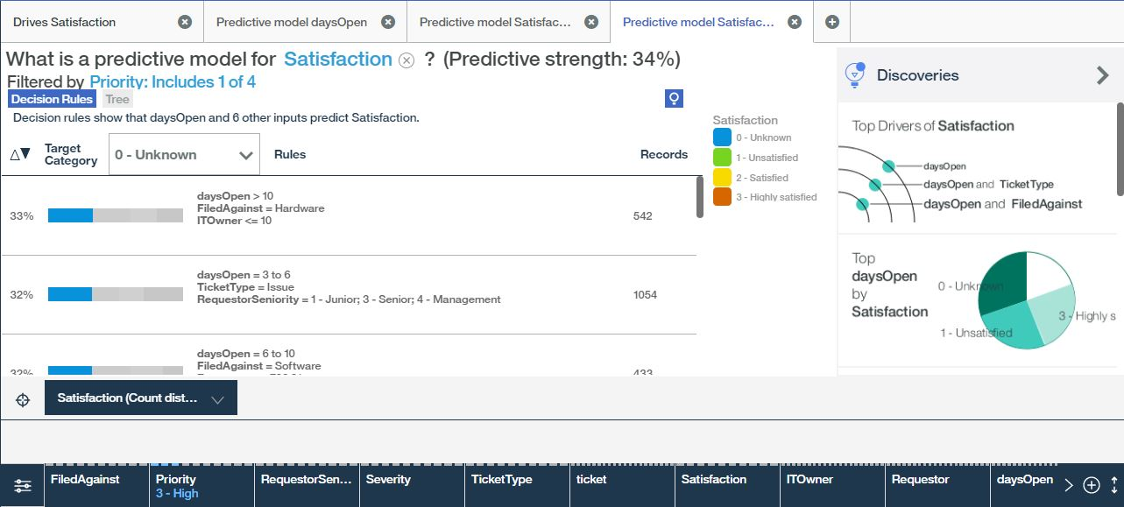

The predictive model for satisfaction based on a priority level of 3 shows a 33% rate when the ticket has been open less than 10 days, filed against a hardware issue, and IT owner is less than 10. The second rule at 32% states the days open is between 3 and 6, ticket type issue, and requested seniority by 1-junior, 3-senior, 4-management.

In conclusion, the lower the severity of the ticketed issue, the higher the priority, the less time required to resolve the issue in a satisfactory manner.